Yesterday’s Weather Forecasting Pattern

We have used this tool to analyze the team’s progress by generating yesterday's weather of Sprint 1 and used the data to forecast Sprint 2 capacity.

1. **Calculation Explanation:**

|  |  |
| --- | --- |
| **Theoretical capacity** | If all members of the team are available as planned (0 = not available, 1 = fully available) |
| **Actual Capacity** | It’s the sum of Actual Availability of each team member |
| **Team Capacity** | The percentage of Actual Capacity |
| **Assumed Normalized Velocity** | Normalized velocity is calculated as the number of points completed in a Sprint, divided by the percent team capacity in that Sprint |
| **Sprint Buffer** | The percentage of velocity to be reserved for unplanned stories that come up during the sprint |
| **Targeted points** | The team's "percent capacity" for the upcoming Sprint is displayed and the number of points (excluding buffer) that the team should bring into the Sprint. |

**  
 Table.1. Showing the availability of team on the regular basis  
  
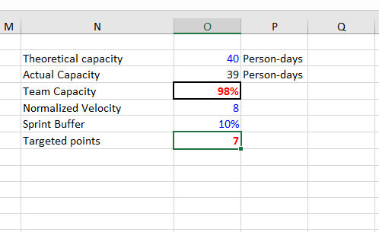  
Table.2. Showing the rationale for upcoming Sprint**

**Targeted points is the Forecast of the number of Story Points deliverable in Sprint 2 based on Yesterday’s Weather Forecast.**

1. **Steps for using this Tool:**

* Enter the names of each team member in "Column B.”
* Enter the fraction of each working day that each team member should be available to the team on a regular basis in cells C2 to L5 (0 = not available, 1 = fully available)
* Type the number shown in cell O3, which is currently your "theoretical capacity" (if all team members are available as planned) into cell O2 At each Sprint Planning Meeting…
* In Cells C2 to L5, update the percent availability for each team member to reflect any known vacation, illness, etc. for the upcoming Sprint.
* Enter the average "normalized" velocity from the past three Sprints in Cell O5. Normalized velocity is calculated as the number of points completed in a Sprint, divided by the percent team capacity in that Sprint.
* Enter the team's current "buffer" (the percentage of velocity to be reserved for unplanned stories that come up during the sprint) in Cell O6
* The team's "percent capacity" for the upcoming Sprint is displayed in Cell O4, and the number of points (excluding buffer) that the team should bring into the Sprint is shown in Cell O7.  **Tool Reference:** https://www.scruminc.com/